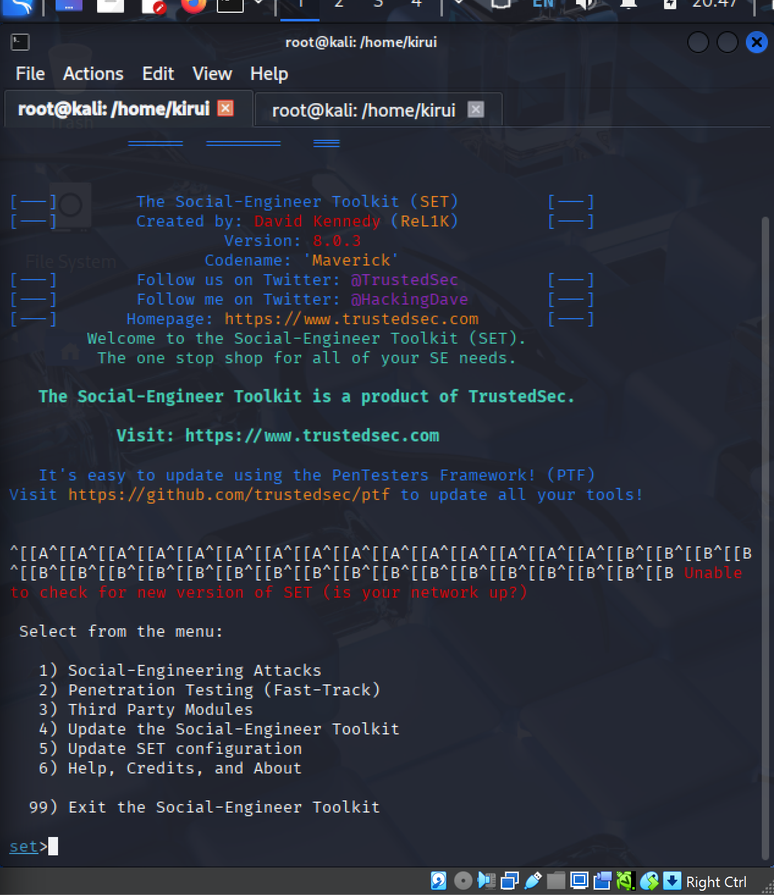
Social-Engineer Toolkit (SET) main interface in Kali Linux.
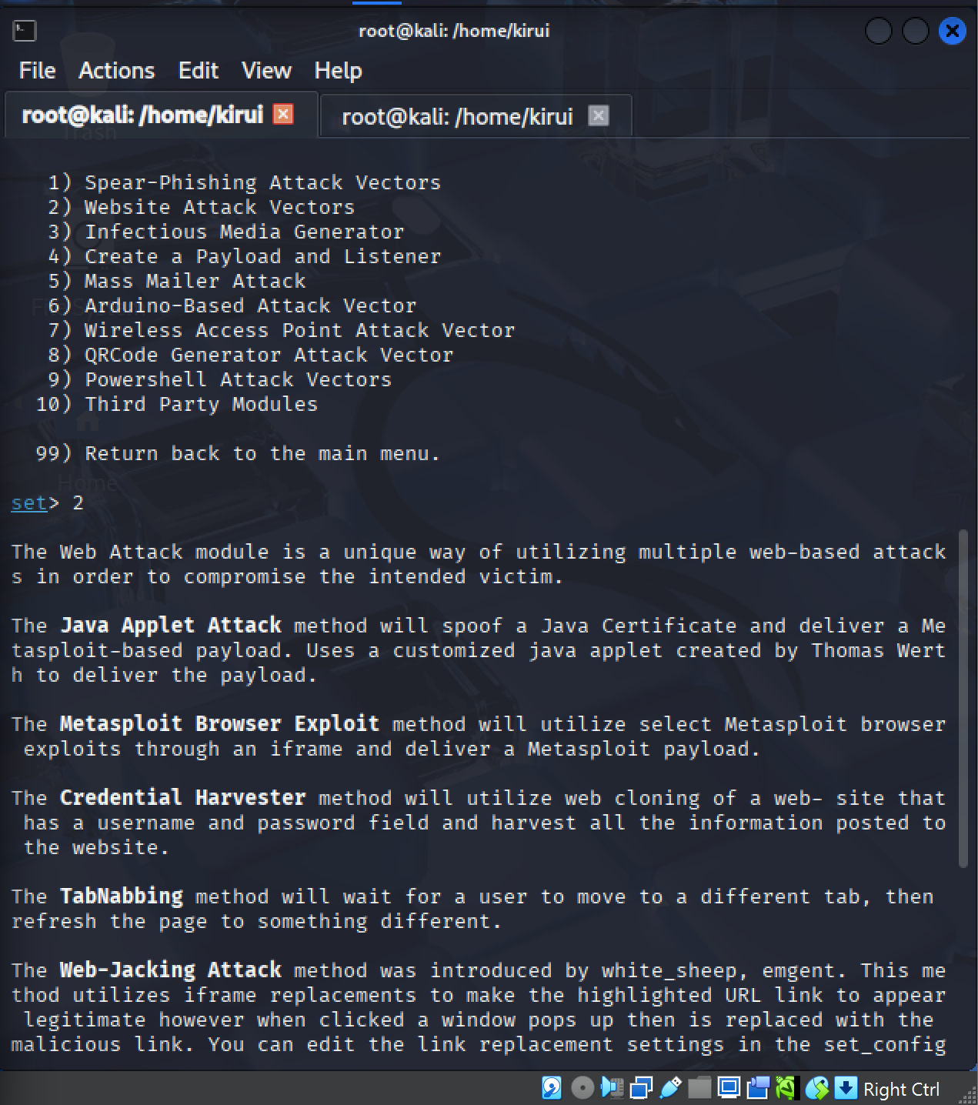

Selecting Website Attack Vectors.
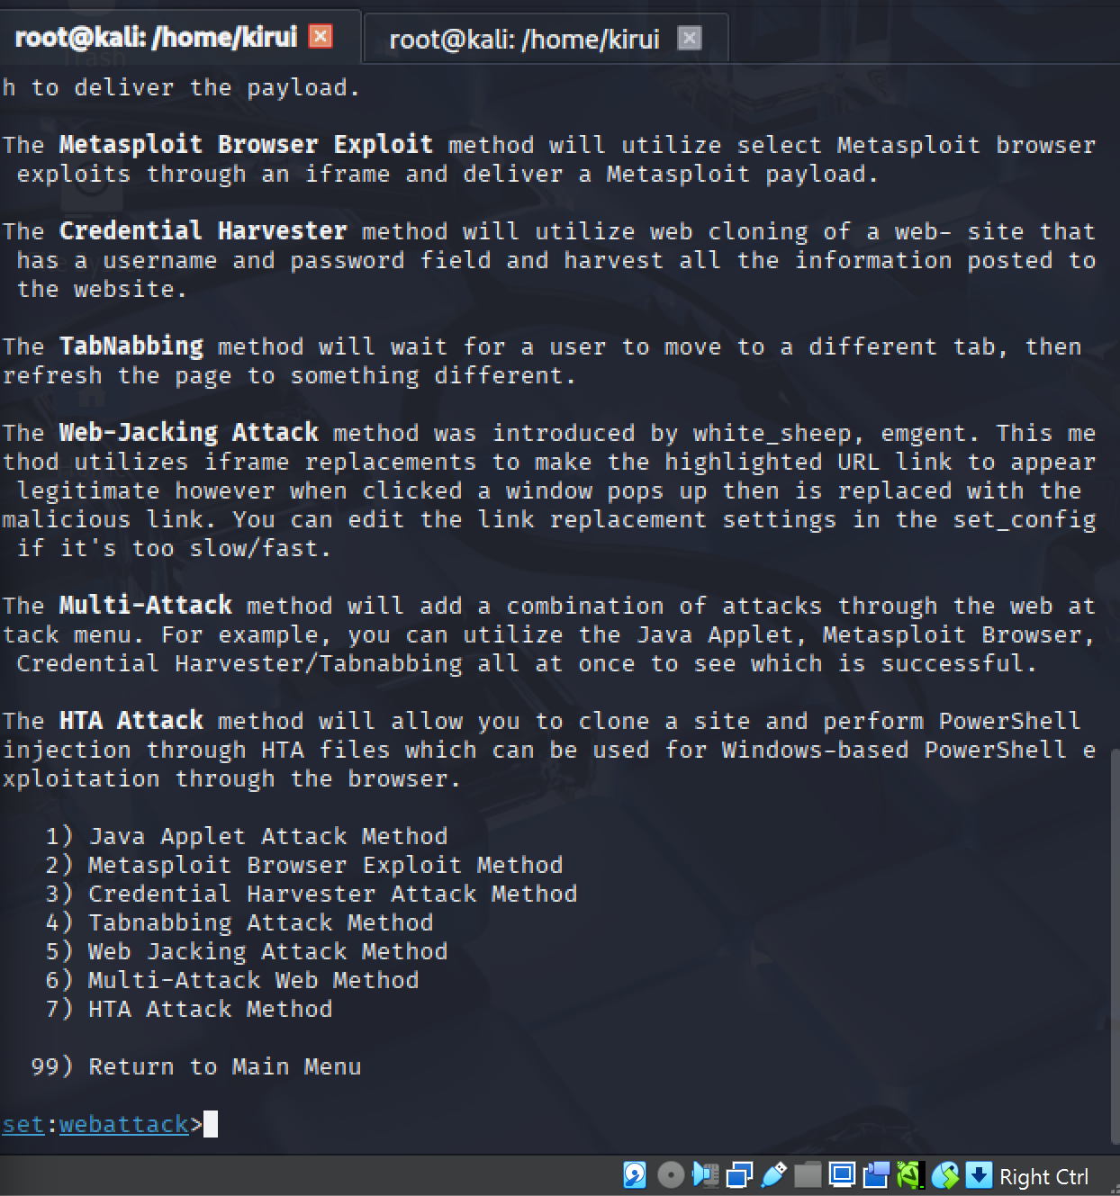
Selecting the "Credential Harvester" module in SET.
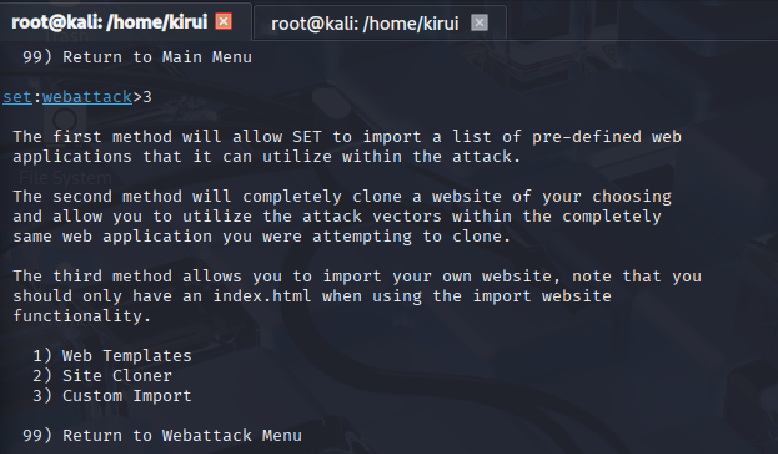

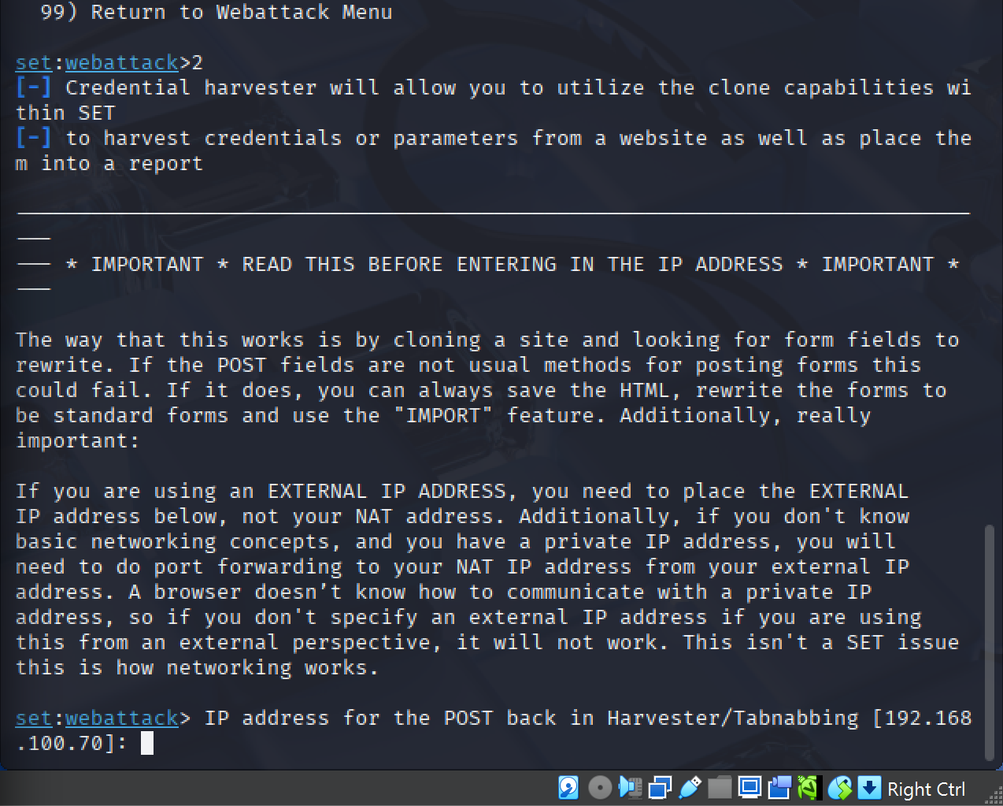

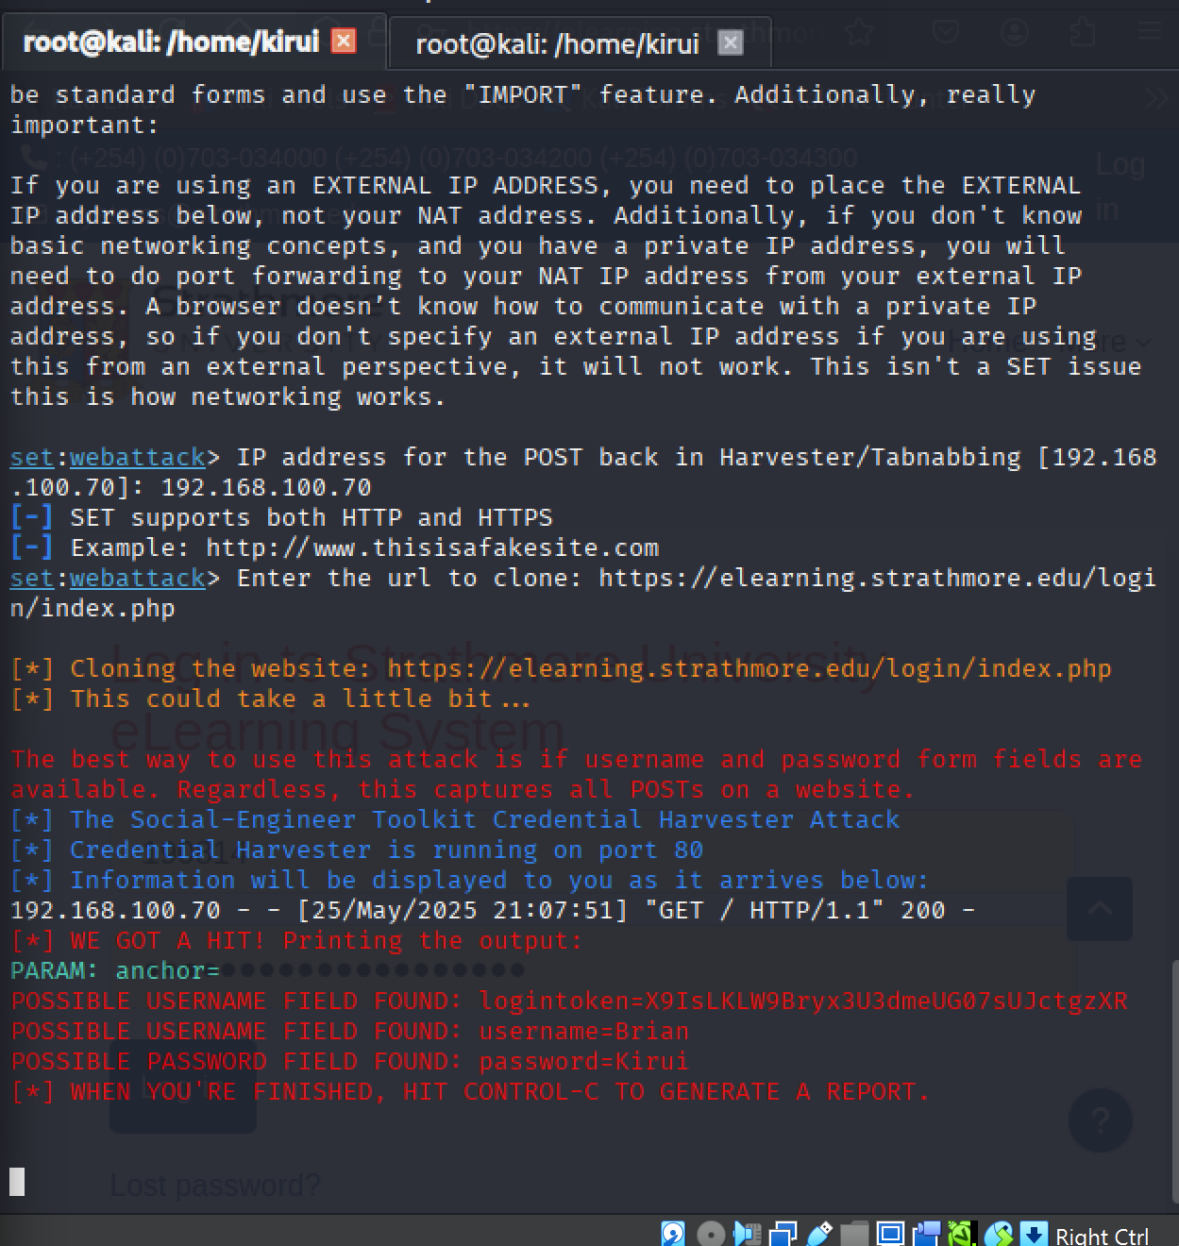Capturing the username and password. The URL used is Strathmore eLearning.

- Issues:
Issue 1 (IP Address):
  - Problem: An IP in the URL is suspicious and not internet-accessible.
  - Solution: Use a domain name and port forwarding.
- Issue 2 (HTTP):
  - Problem: HTTP is unencrypted.
  - Solution: Use Let’s Encrypt for free HTTPS certificates.
- Issue 3 (Ugly URL):
  - Problem: IP-based URL looks fake.
  - Solution: Use a URL shortener (e.g., Bitly) or a convincing domain.
Email Blast
SPF – Specifies which servers can send emails for a domain to prevent spoofing.
Example SPF rule for company.com:
v=spf1 ip4:123.45.67.89 include:gmail.com ~all
DKIM – Adds a digital signature to verify email authenticity.
DMARC – Tells receivers how to handle emails failing SPF/DKIM checks.

Attached.

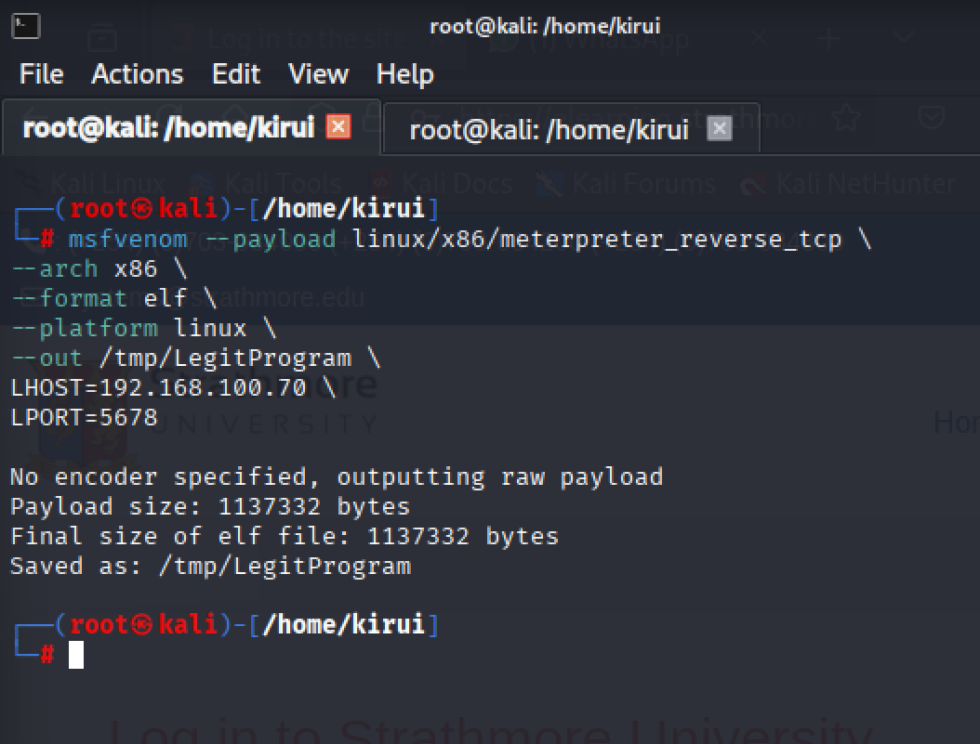
Launching msfvenom on Kali terminal.
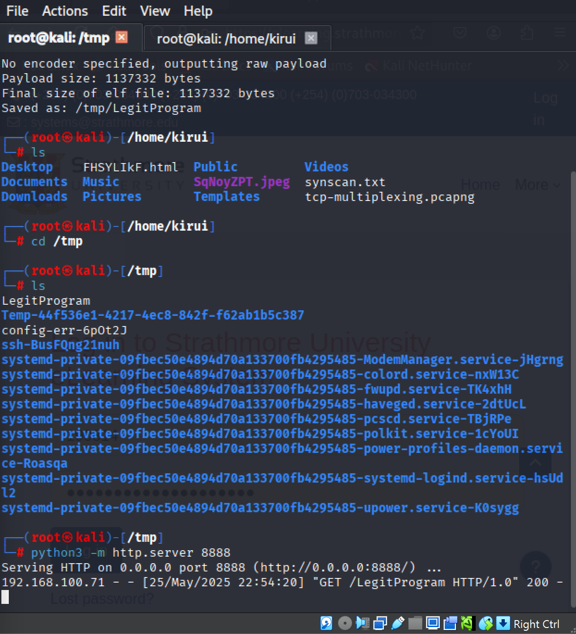
In /tmp directory, we can see our generated LegitProgram. And running Python script.
IP 192.168.100.71 is Metasploitable’s.
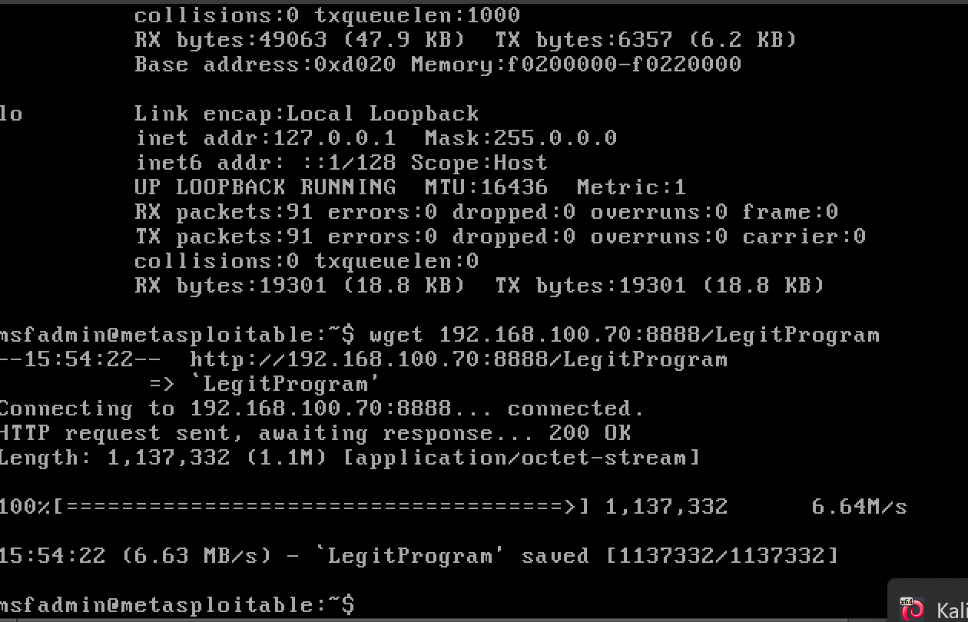
Metasploitable2 VM downloading Legit Program.

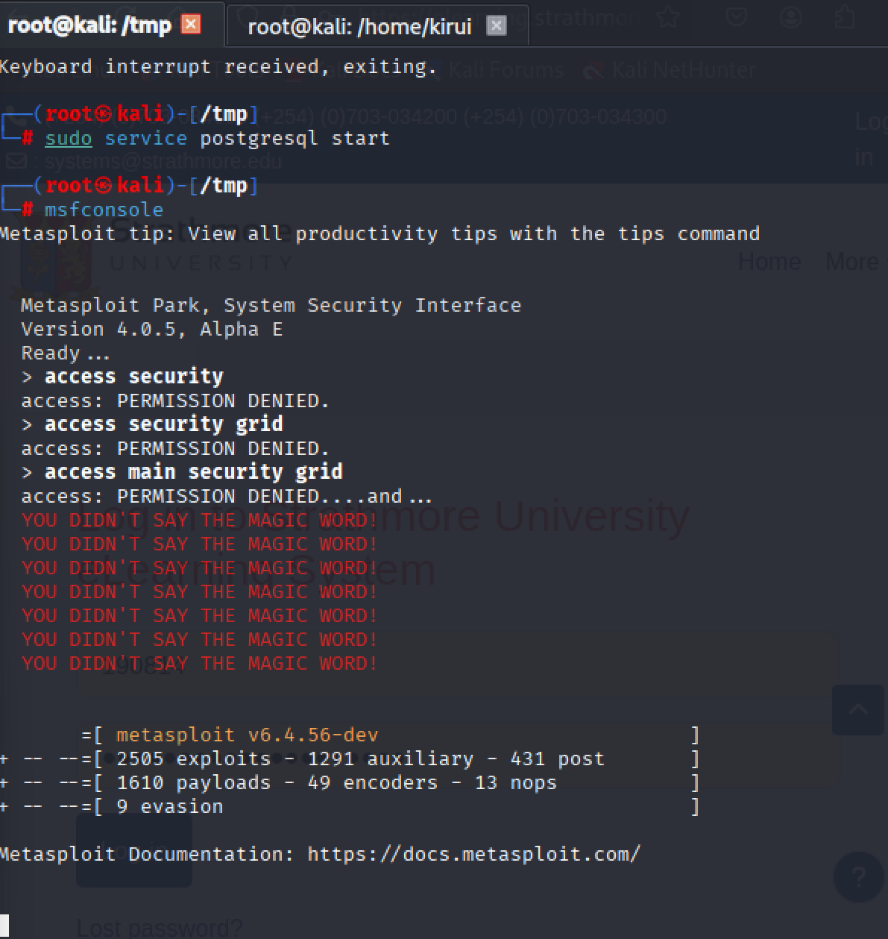
Starting msfconsole.

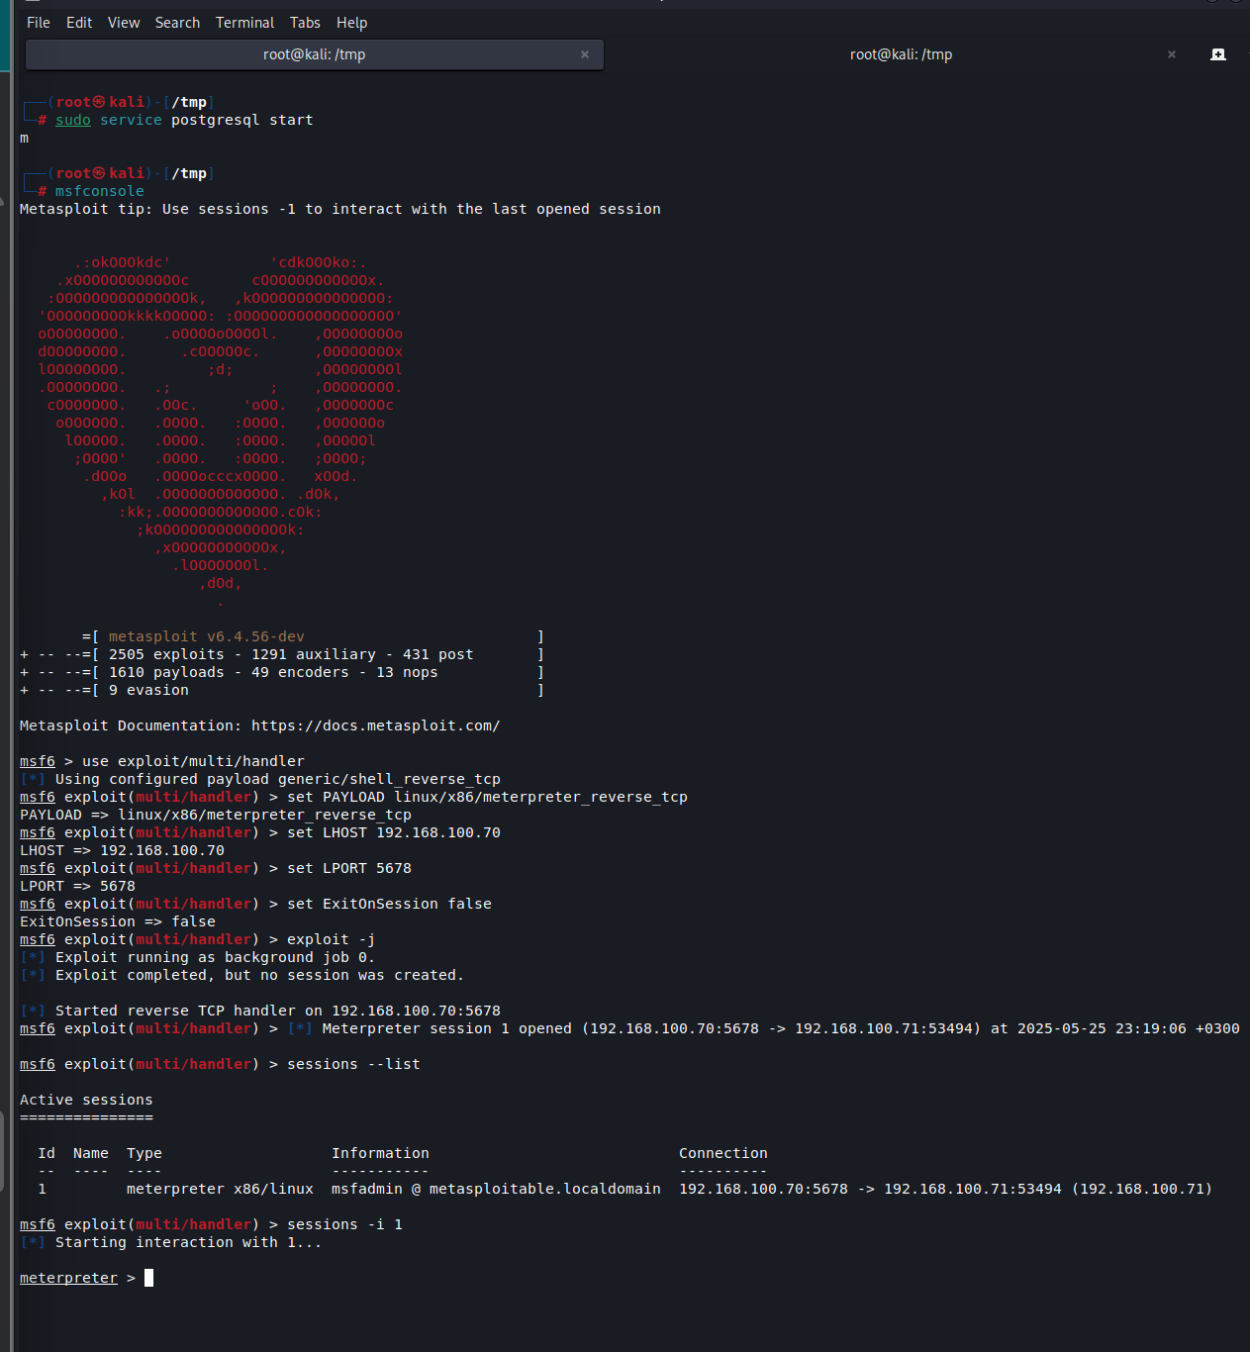Setting up Metasploit and seeing opened sessions.

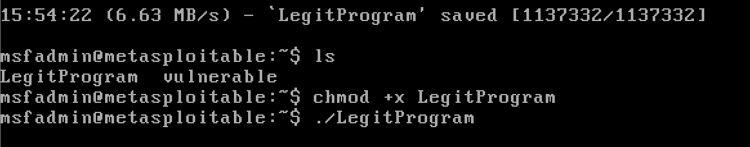
Changing permissions and executing LegitProgram in Metasploitable2.

